KEEP ON ‘COURTING’ YOUR WIFE!

**A ROSE NEEDS LOVE**

A Rose without water will wither.

A Rose without sunlight will fade.

And the Rose without love and attention

Will not live even one day.

So don’t take the love that is given

And crush it and throw it away.

For words that are spoken harshly 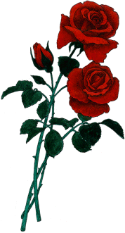

Will cause love to die all the way.

So speak softly to your darling

With tenderness and care,

Then the Rose that you so wanted will bloom to its fullest,

And will grow deeper for you each day.

For in giving your best to your loved ones,

And caring for what they have to say,

You’re saying, «Darling, I love you,»

In one of the most precious ways.

Jesus said, «love one another,»

And without this love we will die,

So water your Rose carefully,

And plant it deep in the love of God’s ways.

--A. Fiasconaro